**Functional specification**

|  |
| --- |
| Functional Specification Document  <SpaceX> |

**DOCUMENT VERSION <V1>**

**<19.05.2019>**

**AUTHORS**

|  |  |  |
| --- | --- | --- |
| **Name** | **Role** | **Department** |
| Alida F. G. Nordhus | Project manager | Digital Development |

**DOCUMENT HISTORY**

|  |  |  |  |
| --- | --- | --- | --- |
| **Date** | **Version** | **Document Revision Description** | **Document Author** |
| 19-05-2019 | V1 | Draft Version | Alida F. G. Nordhus |
|  |  |  |  |
|  |  |  |  |
|  |  |  |  |
|  |  |  |  |

**APPROVALS**

|  |  |  |  |
| --- | --- | --- | --- |
| **Approval Date** | **Approved Version** | **Approver Role** | **Approver** |
| 19-05-2019 | V1 | Development Team Leader | Alida F. G. Nordhus |
|  |  |  |  |
|  |  |  |  |

**Table of Contents**

1. Introduction (give a brief description of the company) 6

1.2 Purpose of the document 6

1.3 Project Scope 7

1.4 Scope of the document 7

2.2 System Actors 9

2.3 Dependencies and Change Impacts 10

3. Functional Specifications 10

3.1 Develop an online site and mobile app 10

6. Reporting Requirements 12

7. Integration Requirements 12

8. References 15

# Introduction

# SpaceX is a company that launches rockets and spaceships. It started in 2002 to develop space technology. The goal is to make it possible for people to live on other planets. They have over 6000 employees, 3 vehicles and over a hundred launches contracted.

# Purpose of the document

# The purpose of this document is to document the business requirements and functional rules of the SpaceX microsite. This document will include a basic mockup of the microsite.

# All system requirements and restraints will be documented.

# Risks and Assumptions

|  |  |  |  |
| --- | --- | --- | --- |
| **Risk** | **Level** | **Impact** | **Responsible** |
| User will not be able to watch live feed from their platform | High |  | Development Team |

# System/ Solution Overview

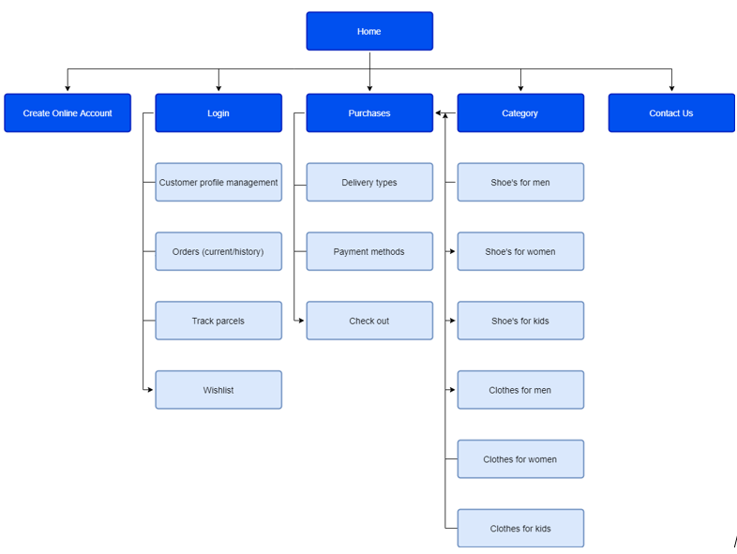

# Functional Specifications

### Develop a microsite for SpaceX.

### Purpose/ Description

## Develop an online microsite for SpaceX to promote their work on space technology.

### Use case

|  |  |
| --- | --- |
| **UC-1** | **Create an online payment page** |
| **Primary Actor(s)** | Customers |
| **Stakeholders and Interest** | CEOBusiness Owner |
| **Trigger** | Create a microsite for SpaceX |
| **Pre-conditions** | Microsite does not exist |
| **Post-conditions** | Microsite page successful |
| **Main Success Scenario** | I go to the SpaceX microsite to find info about space technology and live feed in space.I arrive at the home page and click on the “about” link in the navigation.  * 1. The page takes me to information about space technology.   2. I get a message to click for live feed.   3. The link takes me to a new site with a video.   4. I press play and am able to see video footage of space. |
| **Extensions** | If URL does not work, try google search for SpaceX microsite |
| **Priority** | High |
| **Special Requirements** | An option to get redirected from “about” page to “live feed” page. |
| **Open Questions** | <Notes and questions> |

# Mock-up

# Integration Requirements

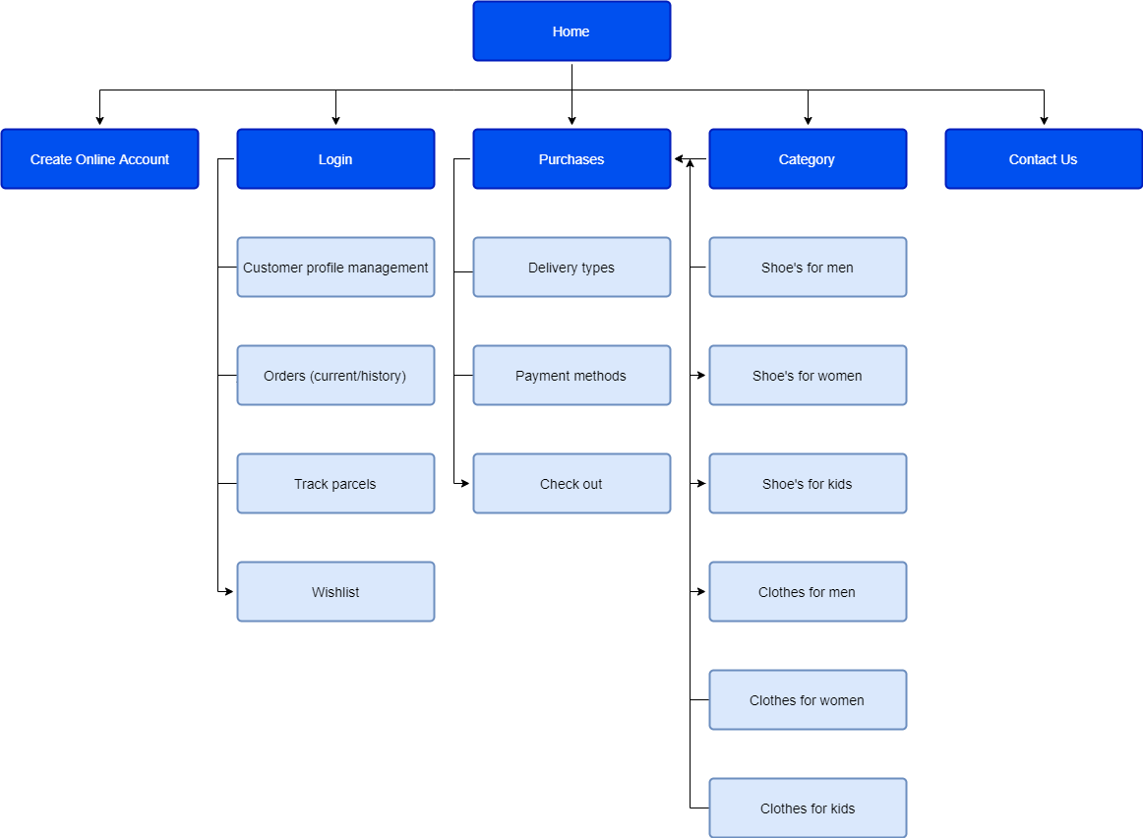

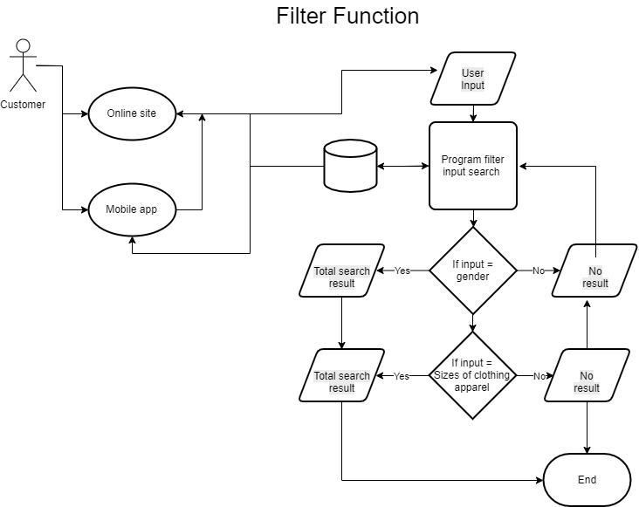

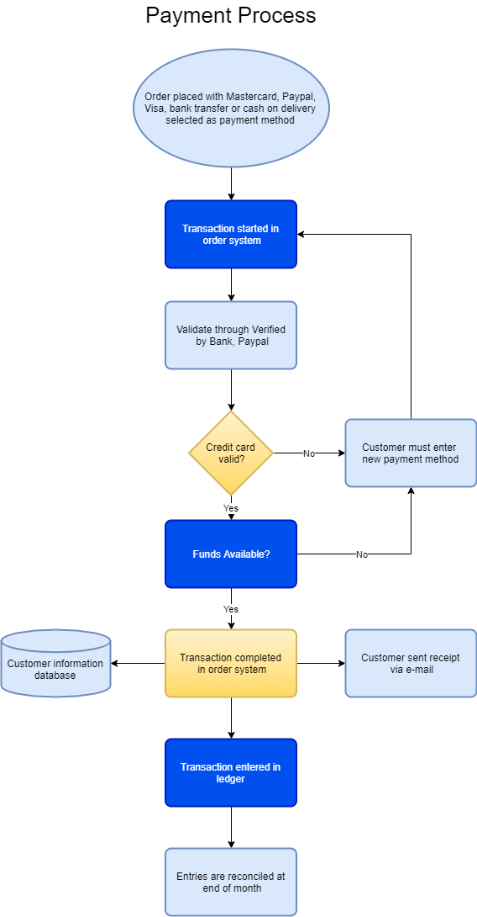

**Project planning document**

For this project exam, I am going to build a microsite page for SpaceX.

I first made a list of elements to include in this project, like these planning documents, use case, personae’s, prototyping, HTML & CSS, JavaScript, design, SEO, target audience and graphic design.

I then put all of them inside the Gantt Chart where I planned the process and how much time I will spend on each. I will do all the research first, then move on to sketches and personae´s/storyboards. After this I will choose colors, design, API and make a prototype of the microsite.   
Then I am going to start build HTML and adding CSS. Further on, I am adding JavaScript, testing it and creating a Git repository.   
For last, I am going to write a report on this process.